Day 17 – Task 2
E-COMMERCE SALES ANALYSIS USING SNOWFLAKE AND POWER BI
Introduction
This project focuses on analyzing e-commerce sales data by connecting Snowflake with Power BI. Snowflake is used to store and manage the sales dataset, while Power BI is used to create interactive dashboards and visualizations to understand business performance.
Objectives
- Create a data warehouse, database and schema in Snowflake.
- Create a table and insert sample e-commerce sales data.
- Verify the data stored in Snowflake.
- Establish a connection between Snowflake and Power BI.
- Perform data cleaning and transformation.
- Create KPI cards and different types of visualizations.
- Develop an interactive sales dashboard using filters and slicers.
Dataset Description
Dataset Name: E-Commerce Sales Dataset
Number of Records: 25
Number of Columns: 13
File Format: CSV
Dataset Columns
- ORDER_ID
- ORDER_DATE
- CITY
- PRODUCT
- CATEGORY
- QUANTITY
- UNIT_PRICE
- DISCOUNT_PERCENT
- SALES_CHANNEL
- ORDER_STATUS
- CUSTOMER_TYPE
- PAYMENT_METHOD
Step by step Procedure:

1. Create a Warehouse in Snowflake
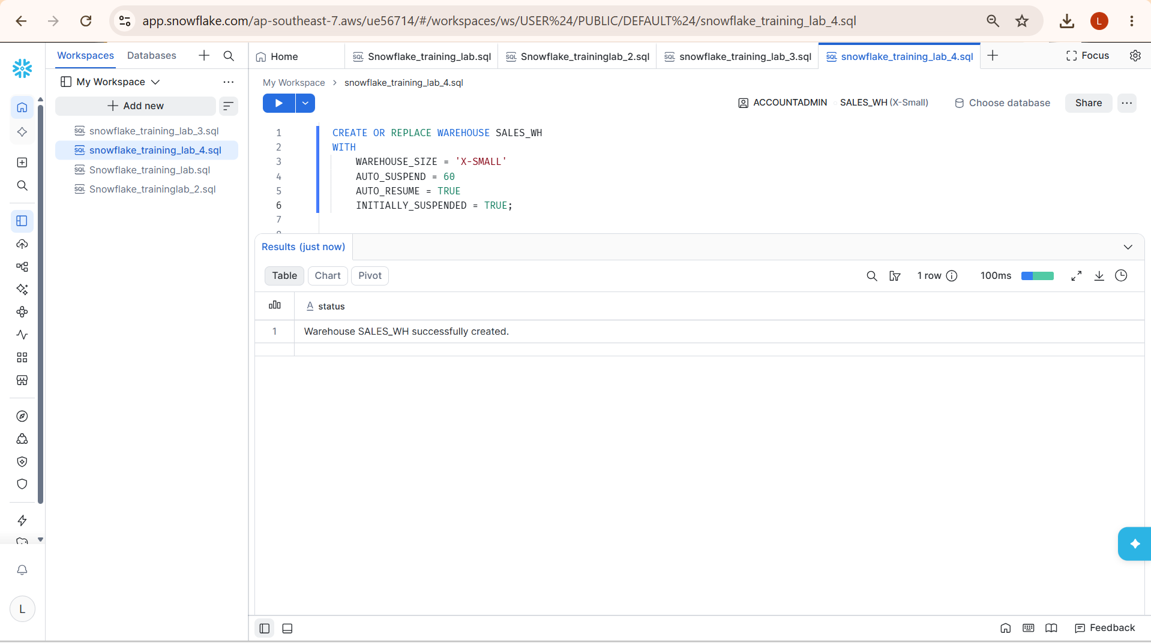
2. Create a Database and Schema
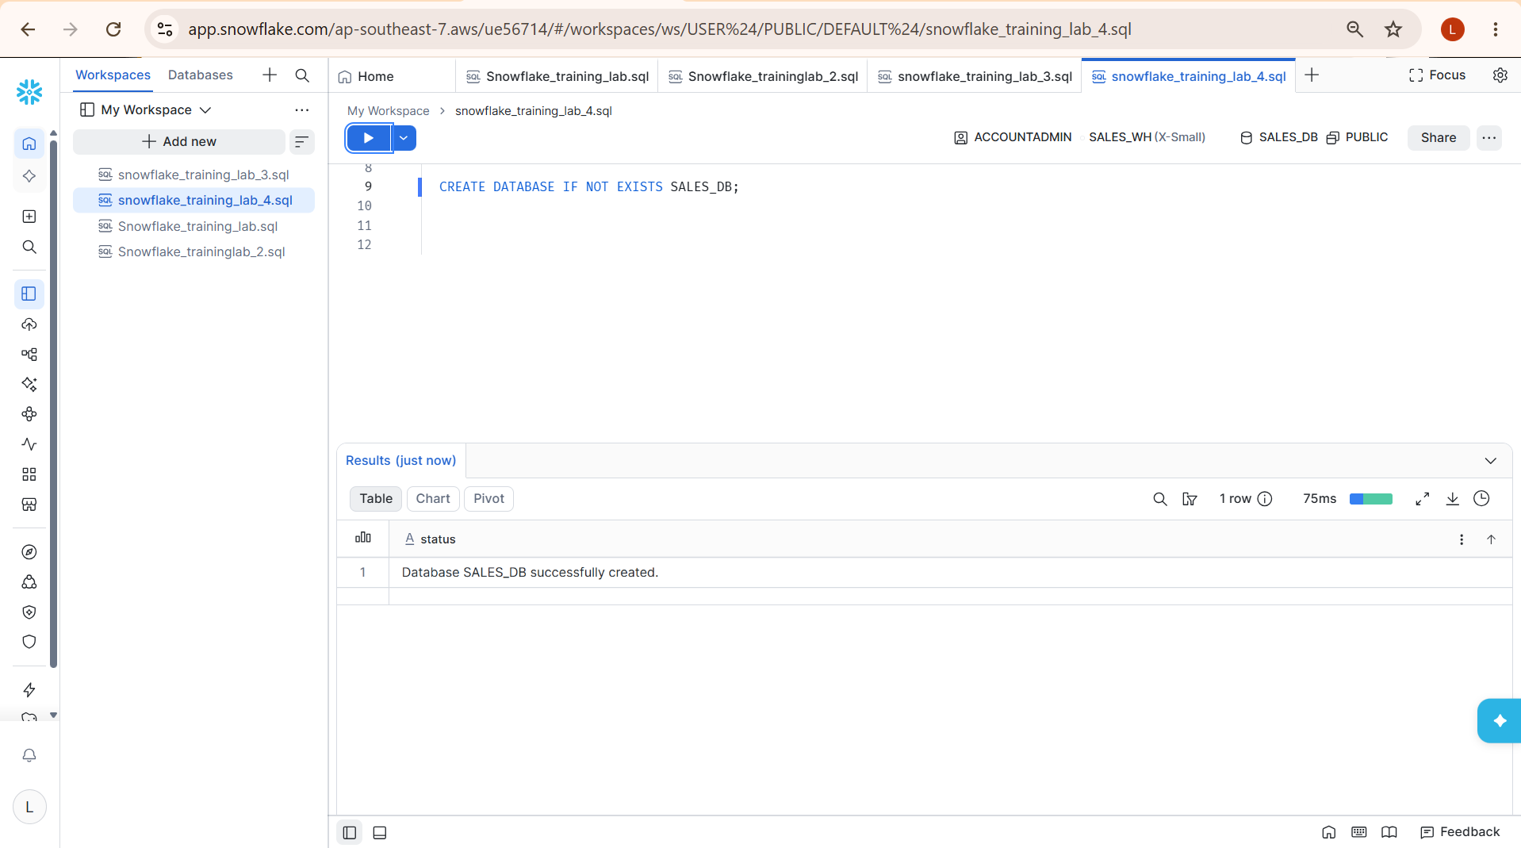
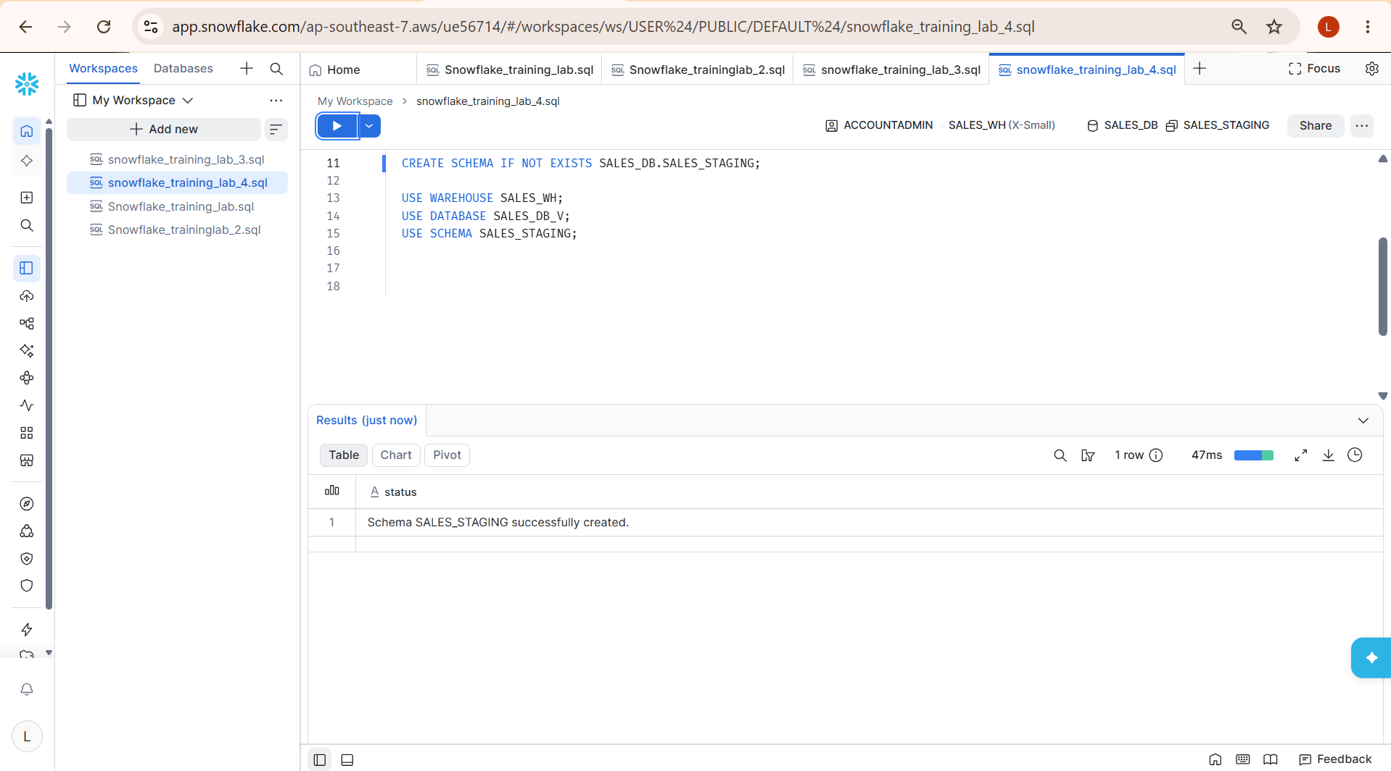

3.Create a Table
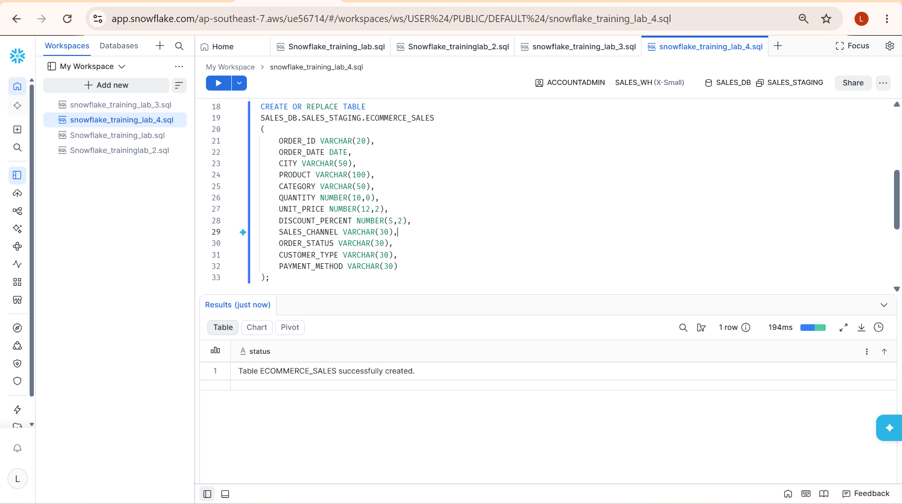

4. Load the Data
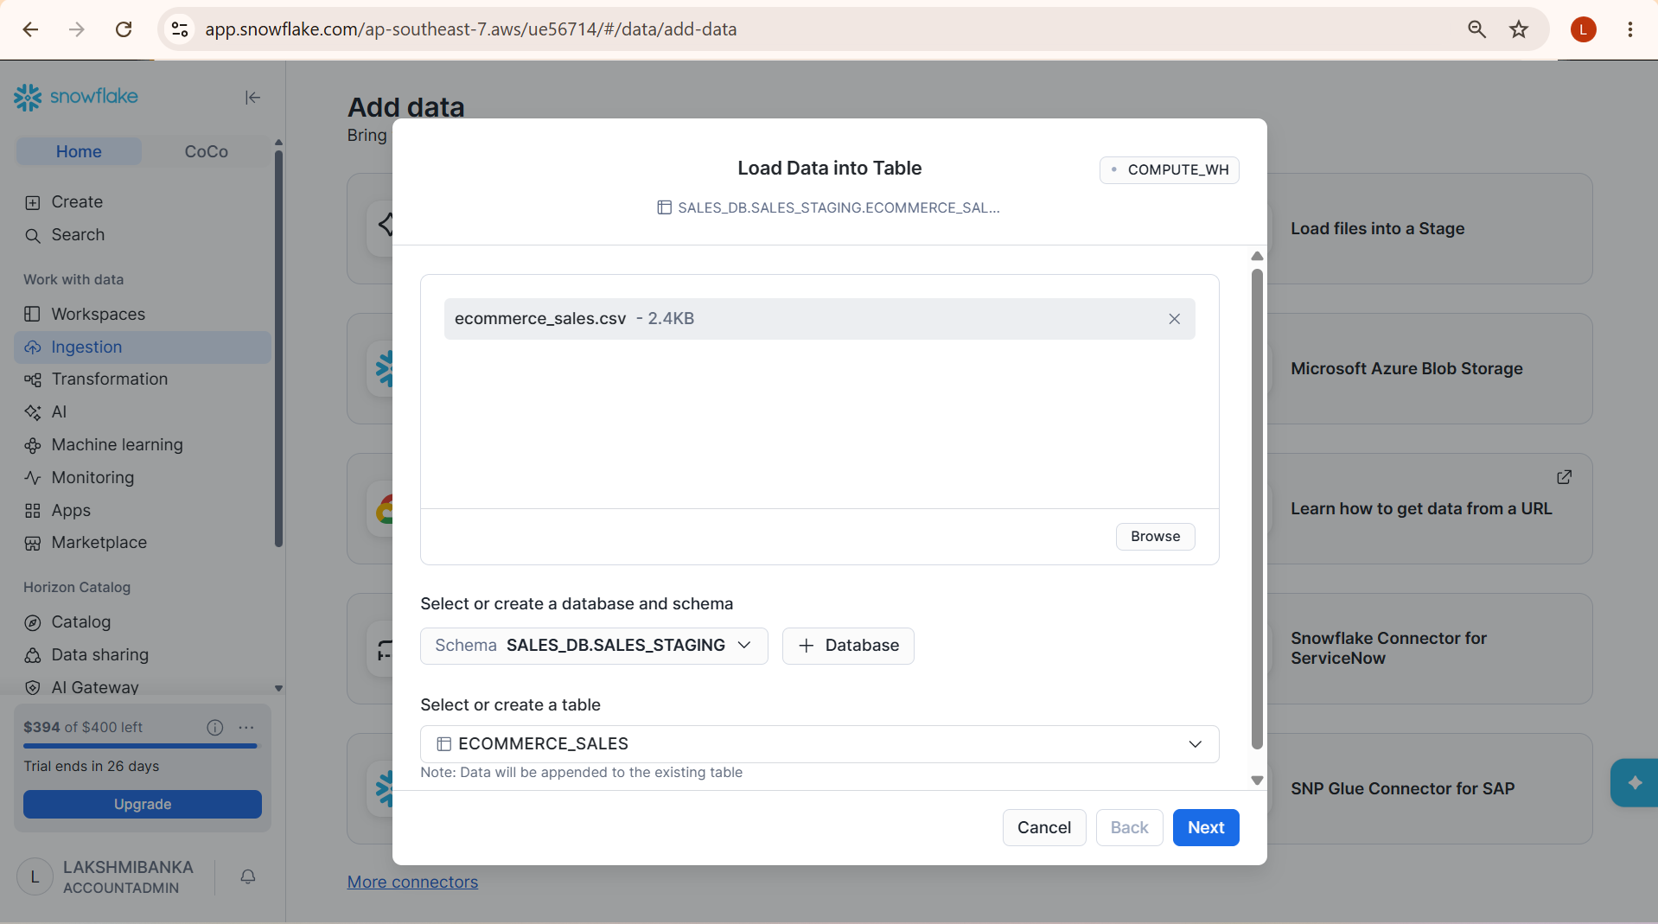

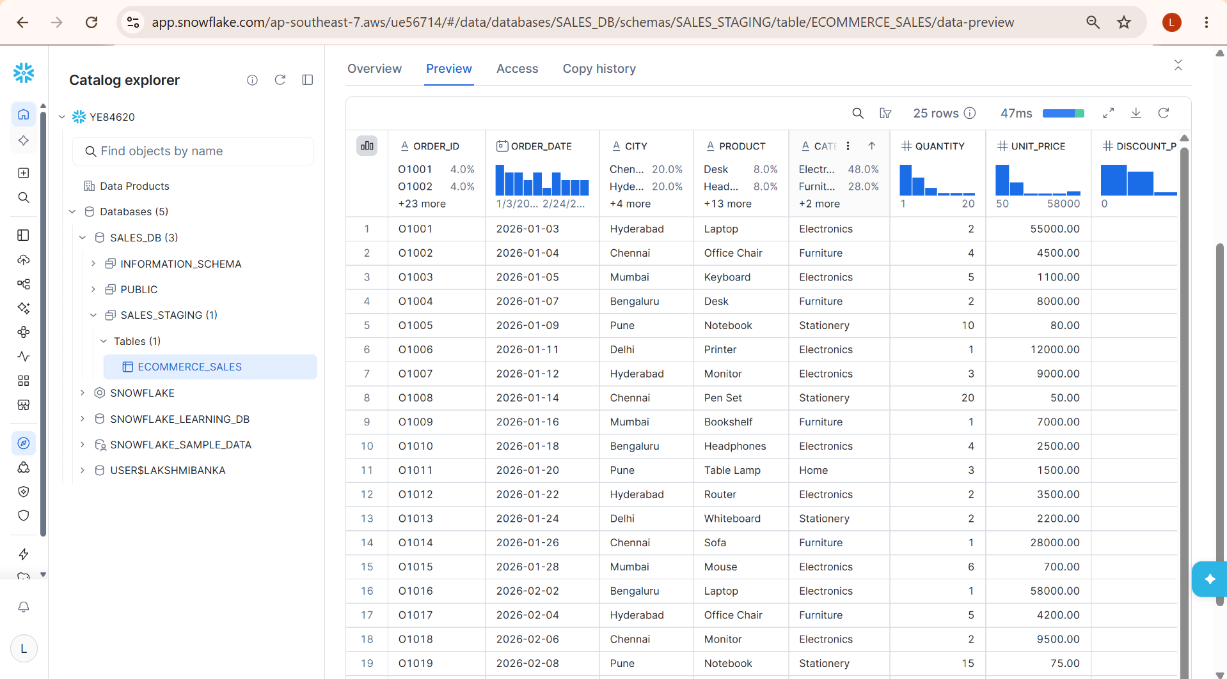

5. Verify the Data
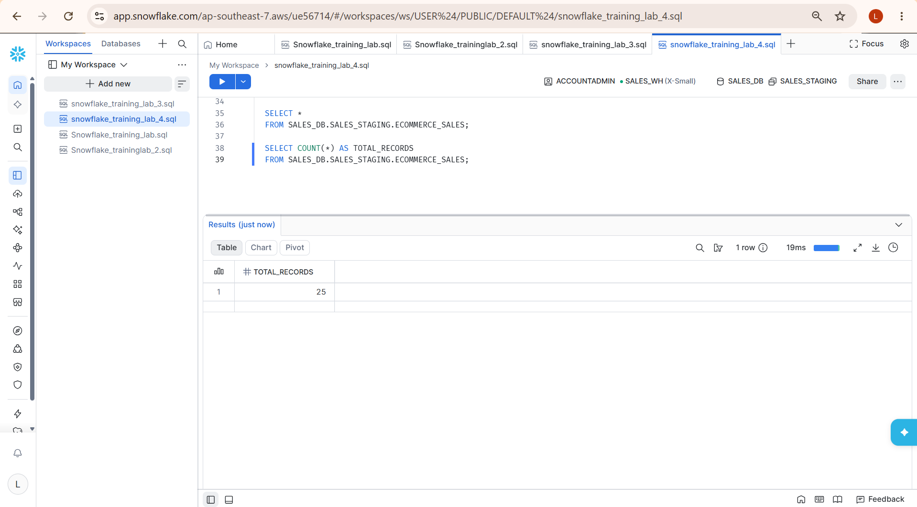

6. Connect Snowflake to Power BI
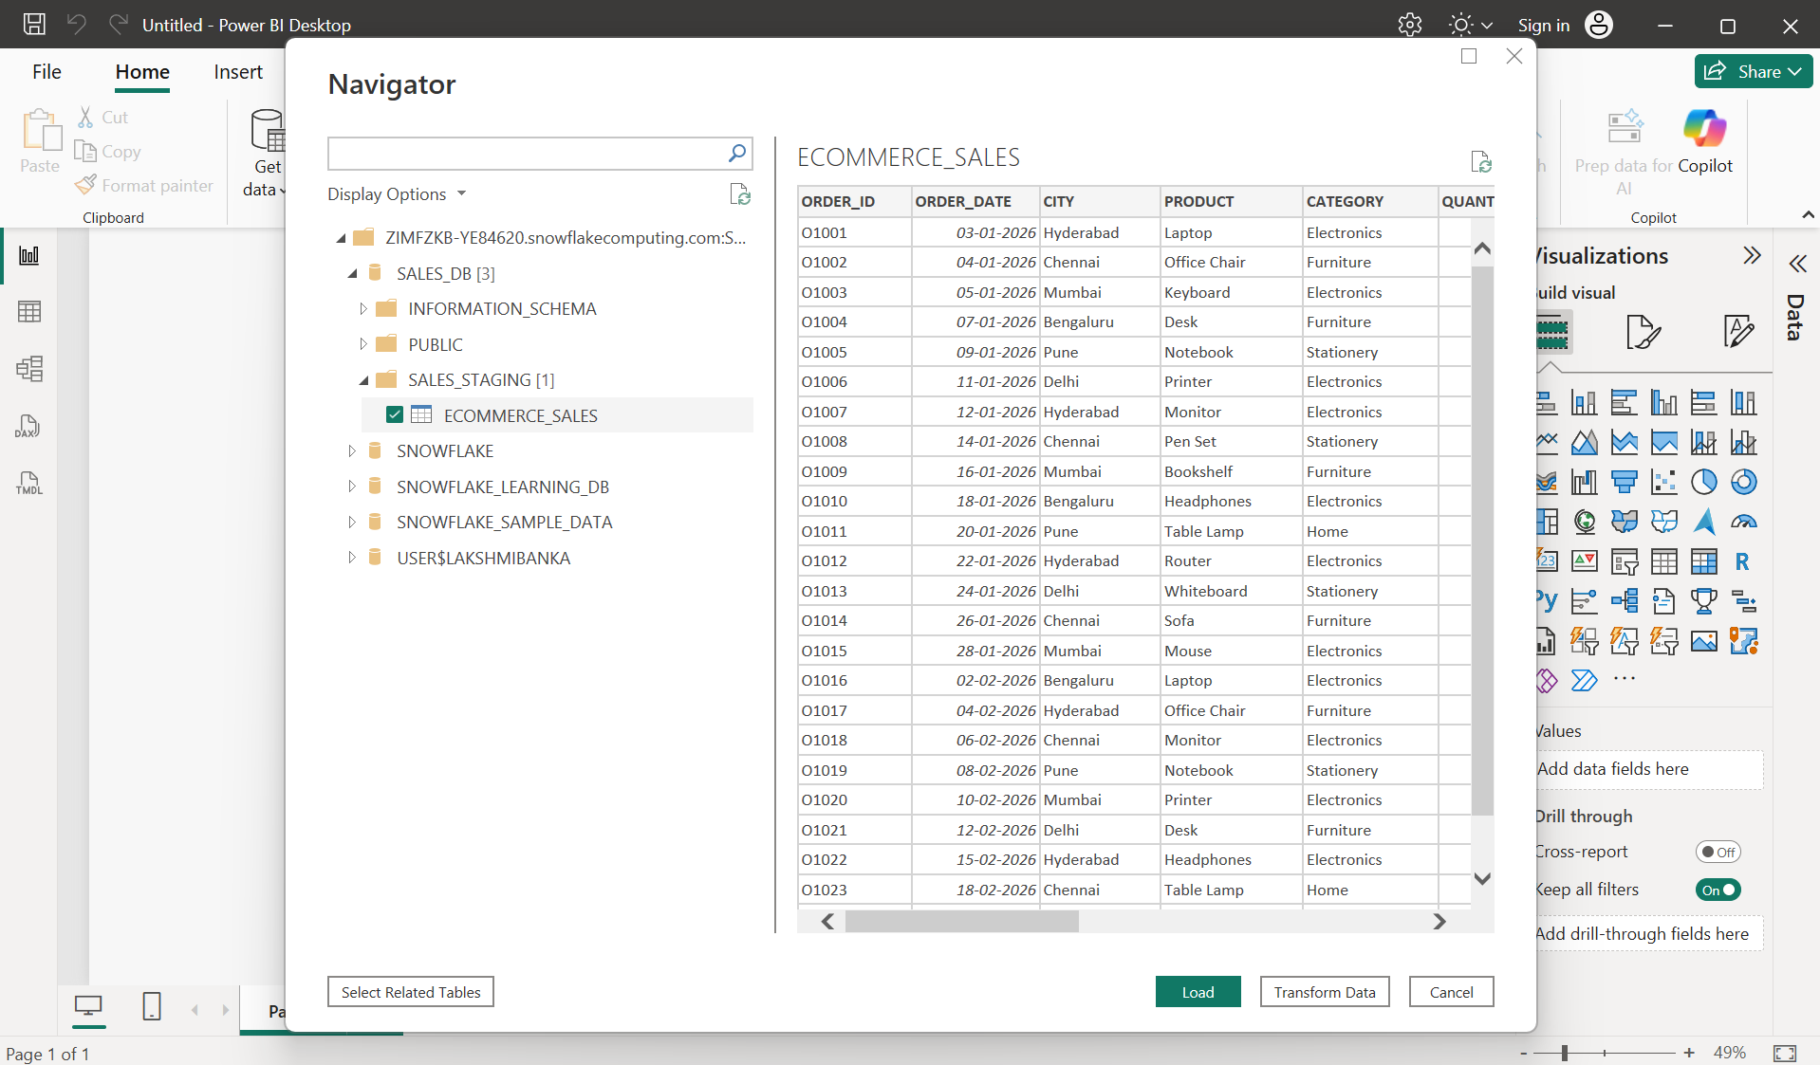

7. Clean and Transform Data Using Power Query
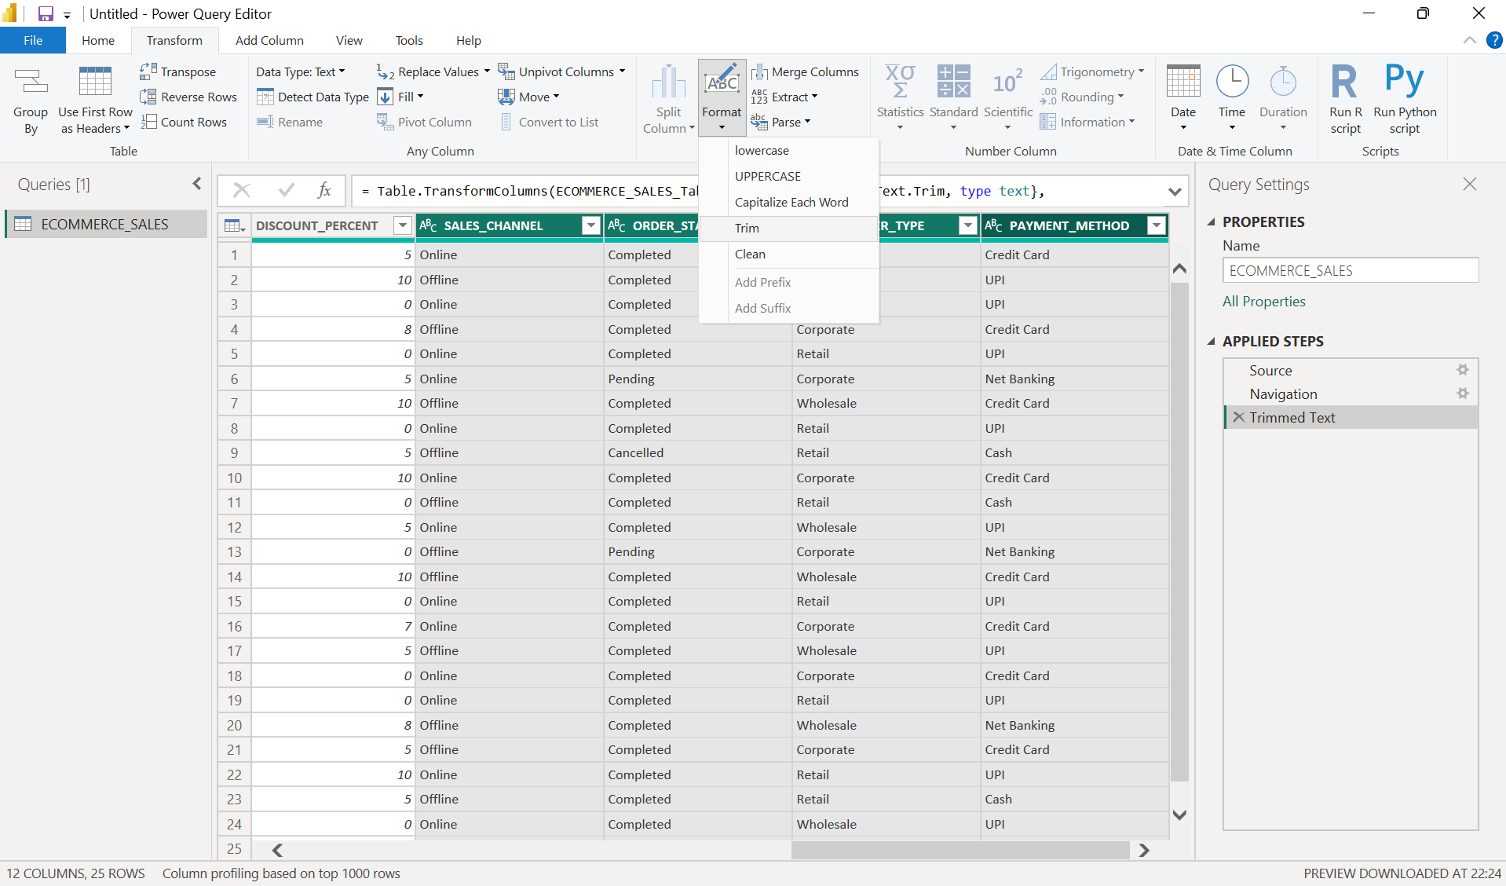

8. Create Calculated Columns
Revenue
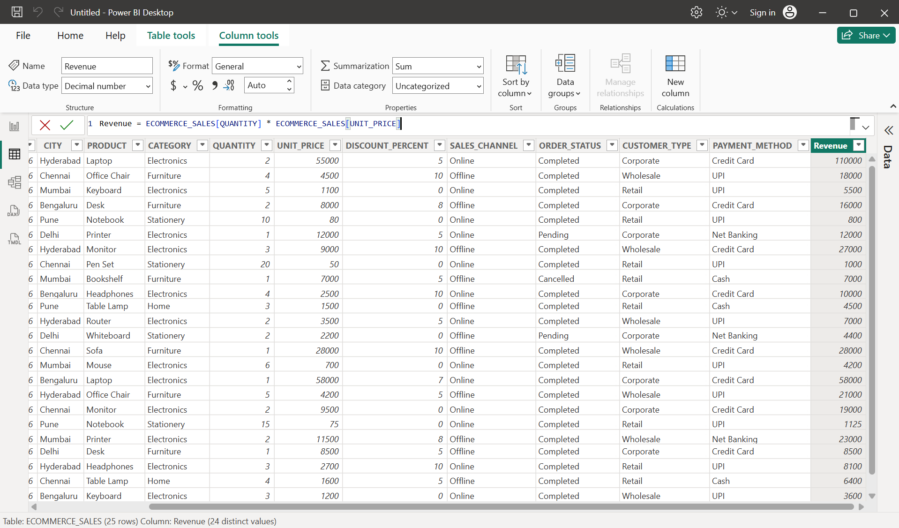

Discount Amount
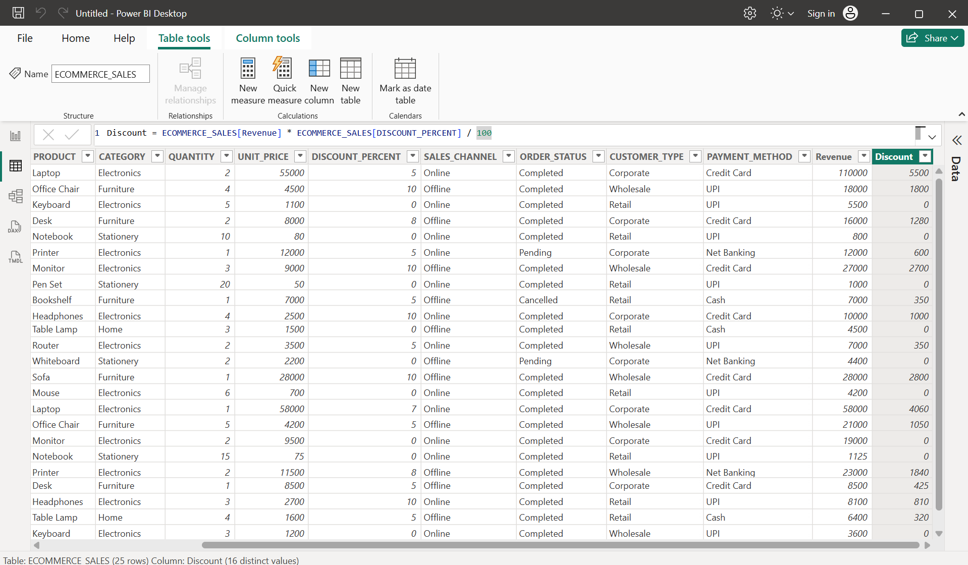

Final Amount
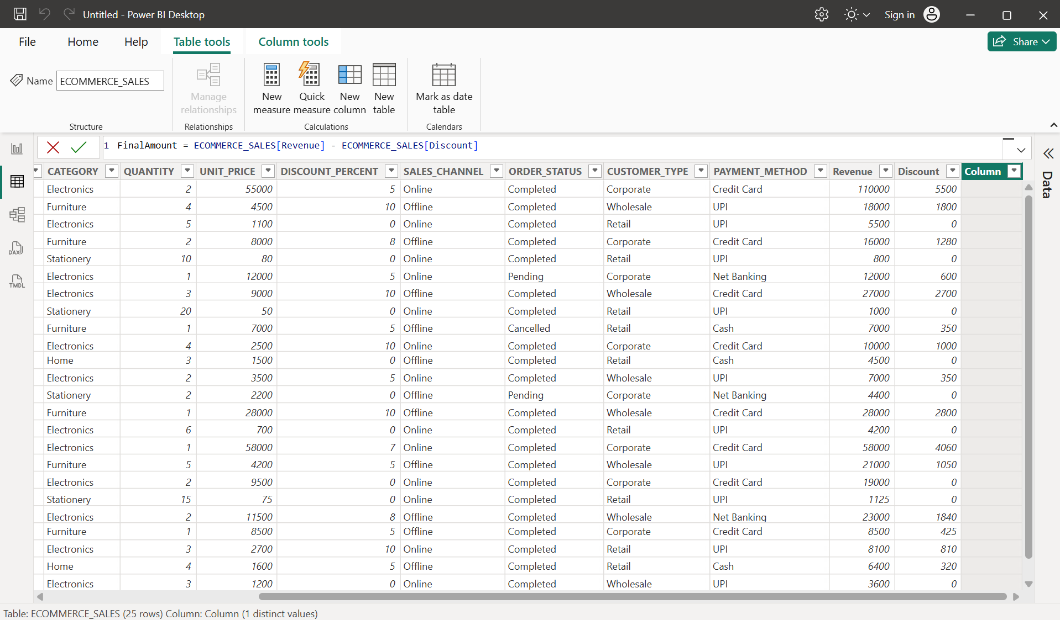

Order Month
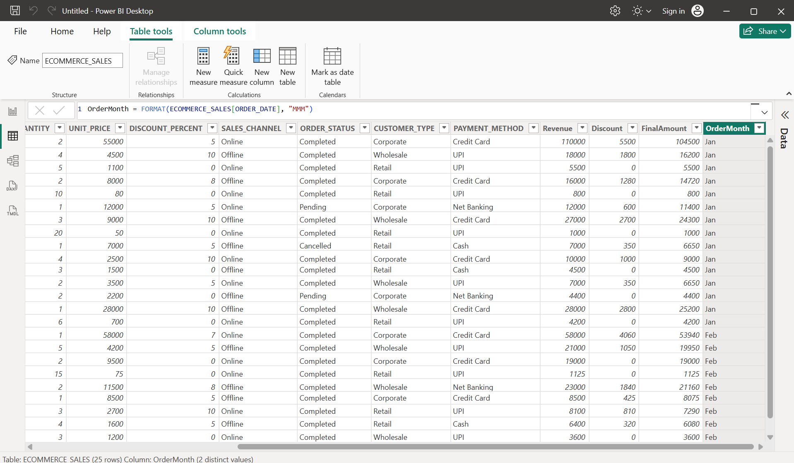

Order Month Number
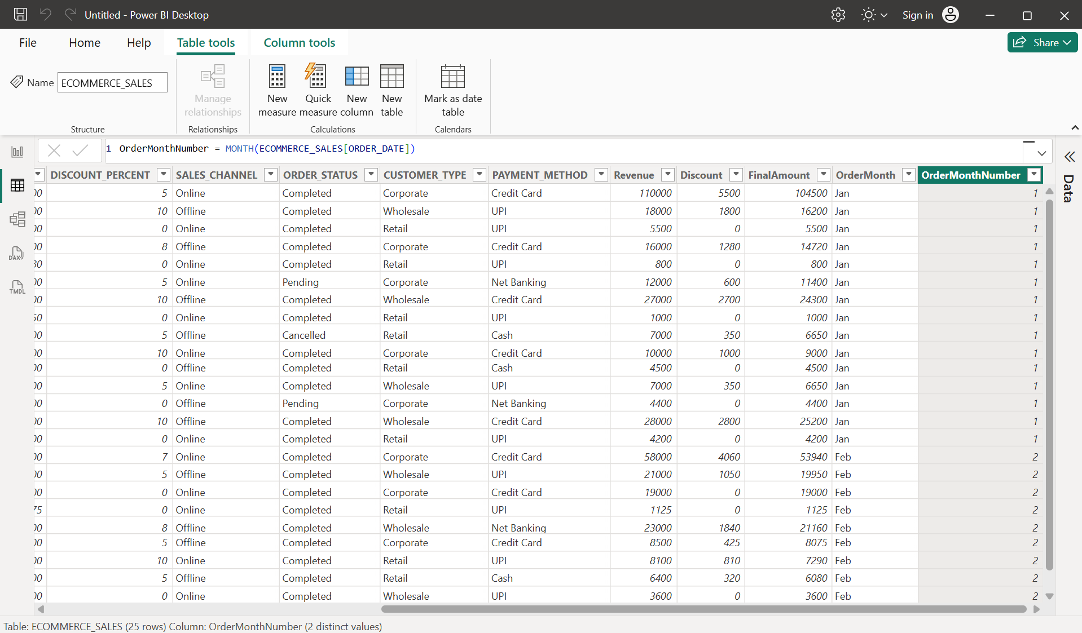

Order Year
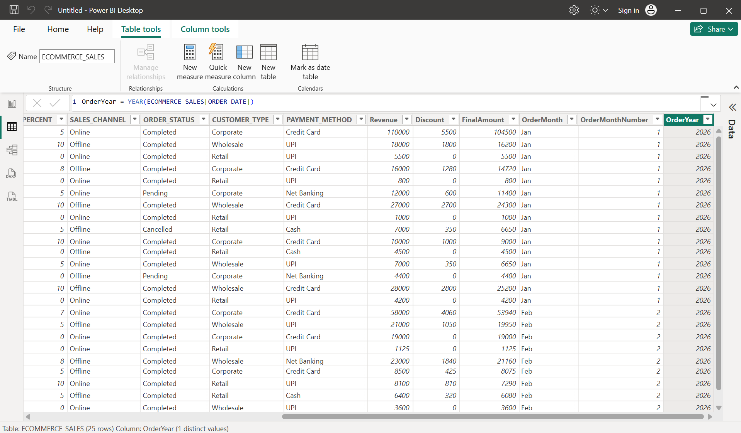

9. Create Measures
Total Orders
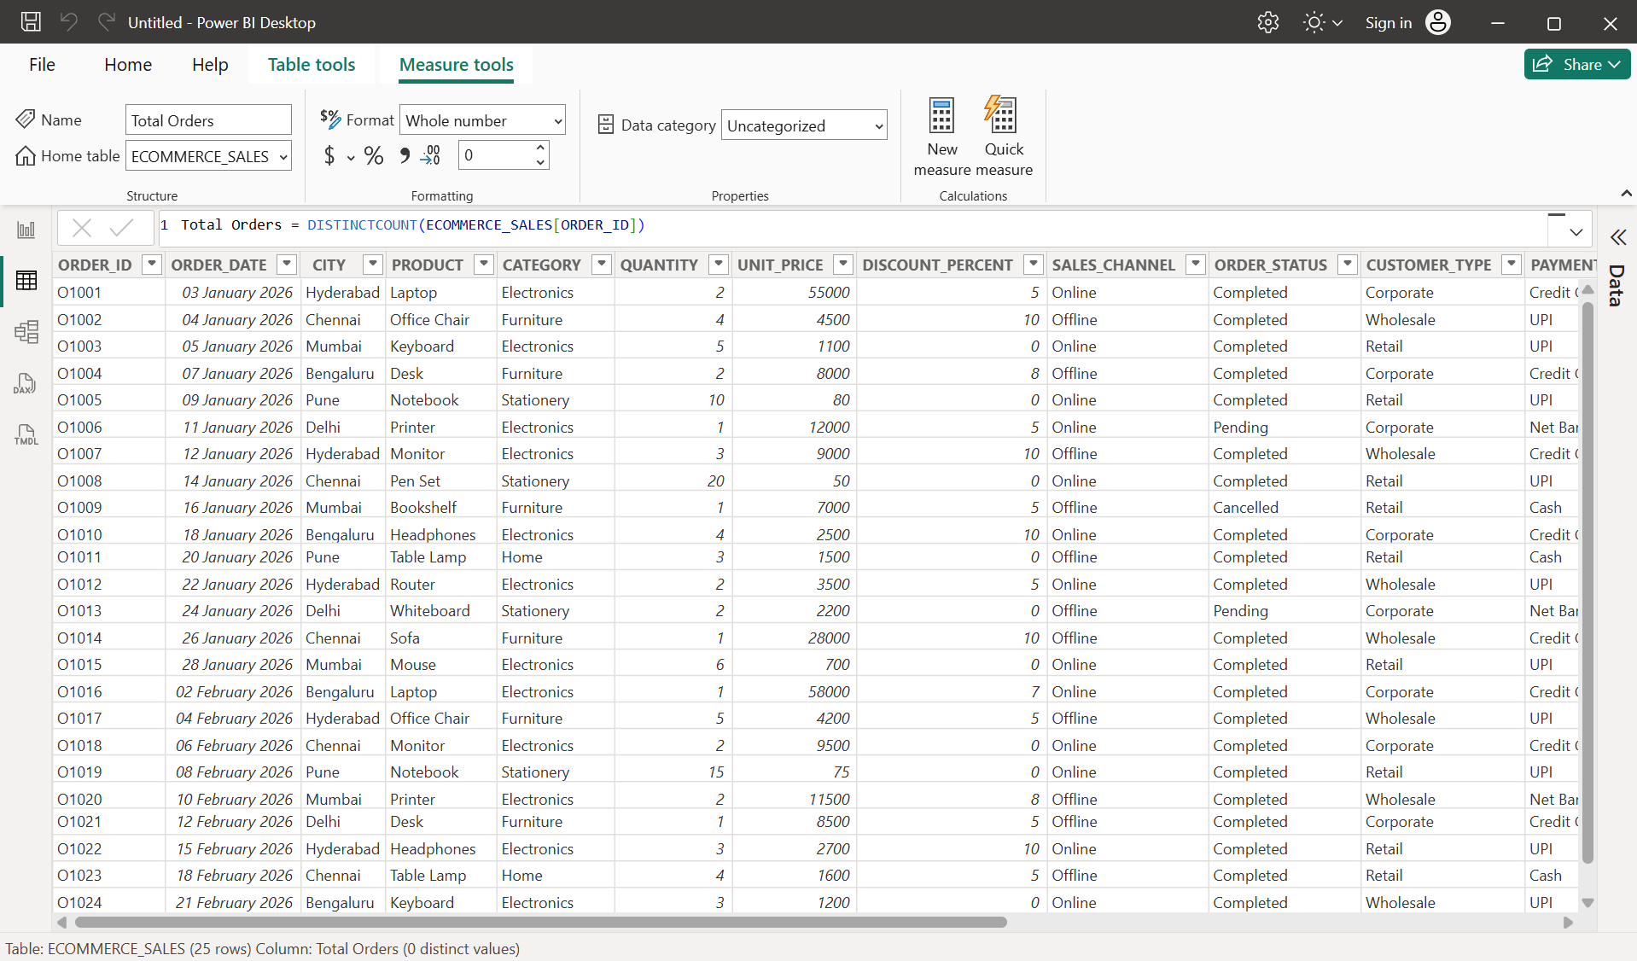

Total Revenue
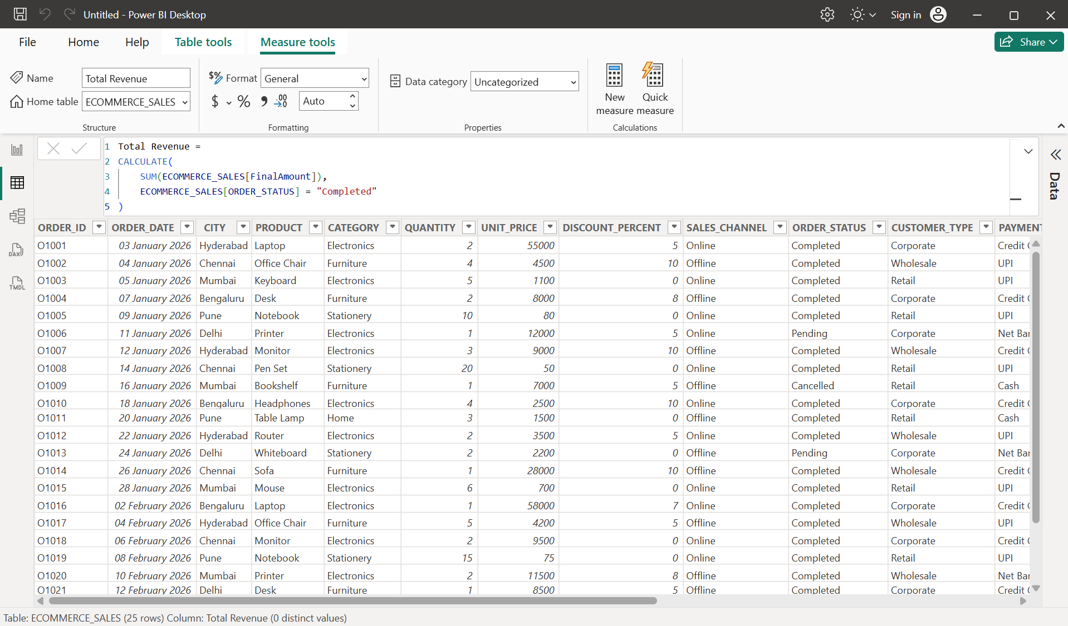

Average Order Value
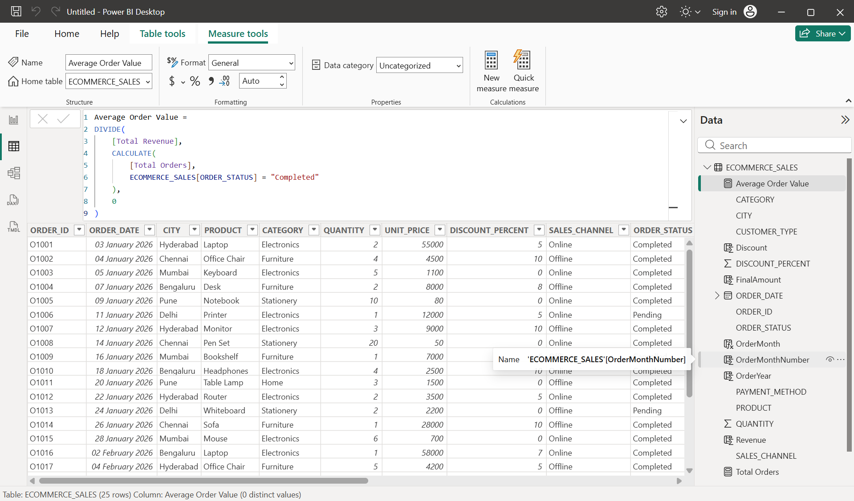

Total Units Sold
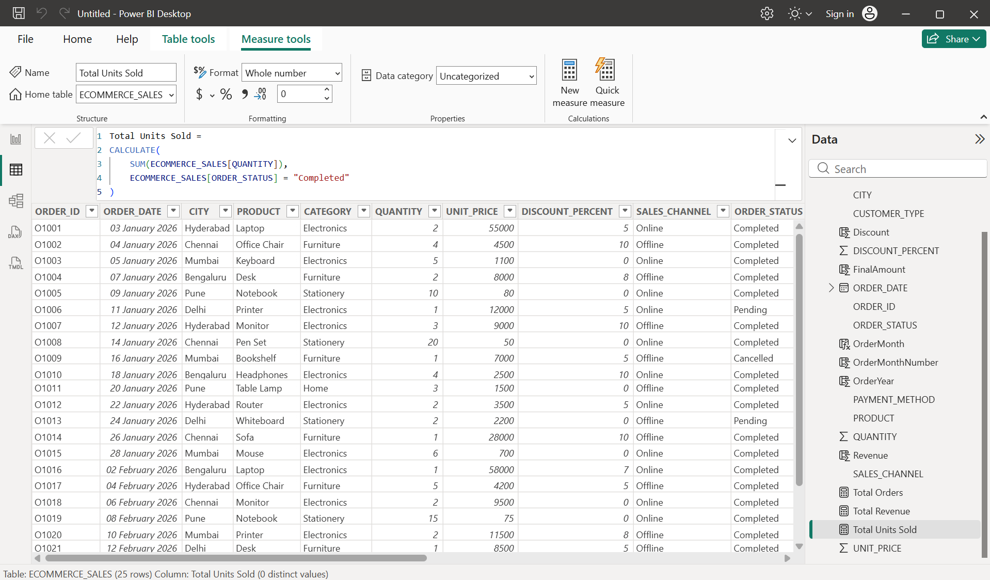

Total Discount
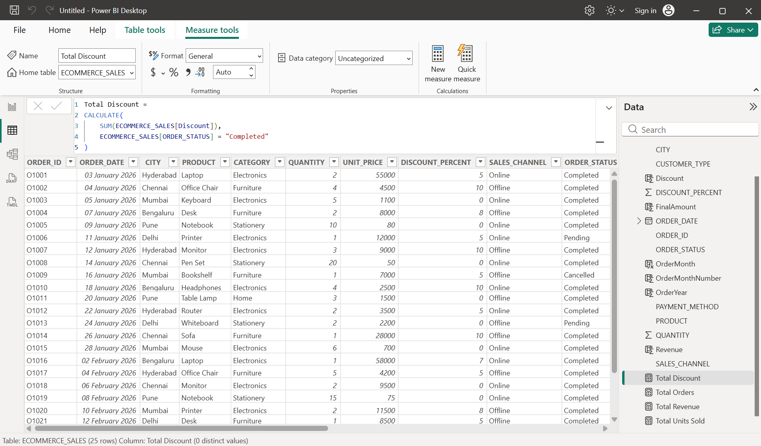

Completed Orders
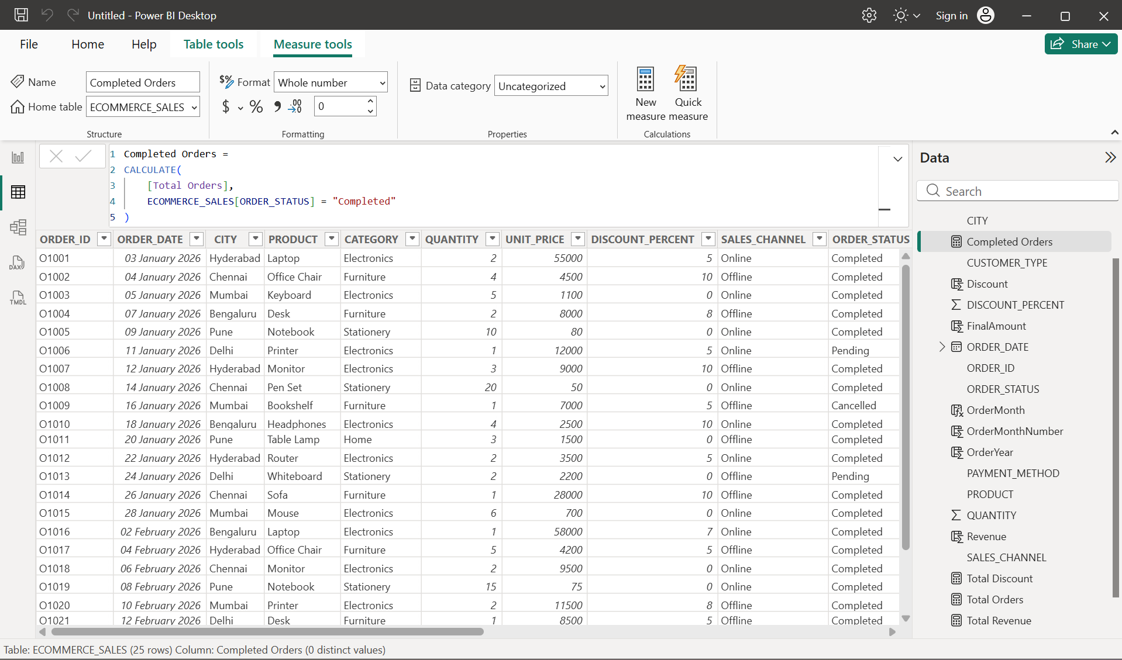

10. Create KPI Cards
Dashboard:
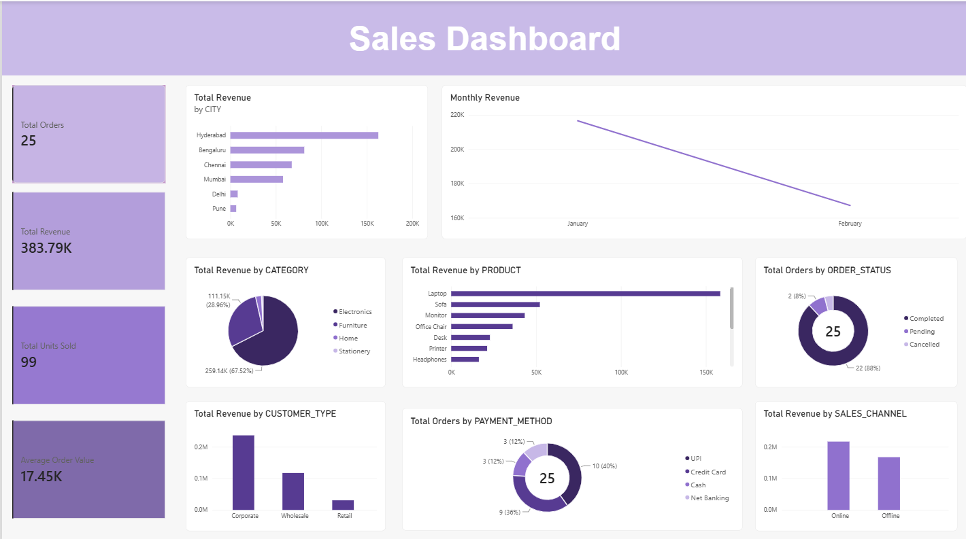
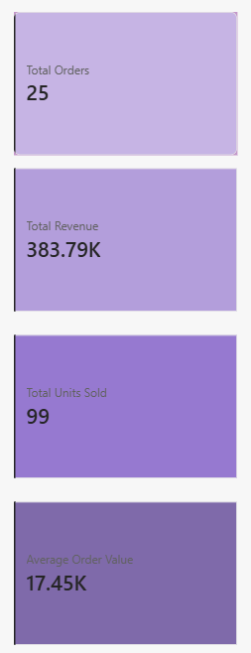

11. Create Visualizations
Revenue by City
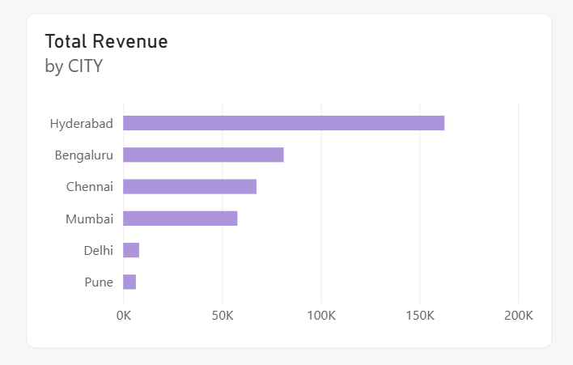

Monthly Revenue
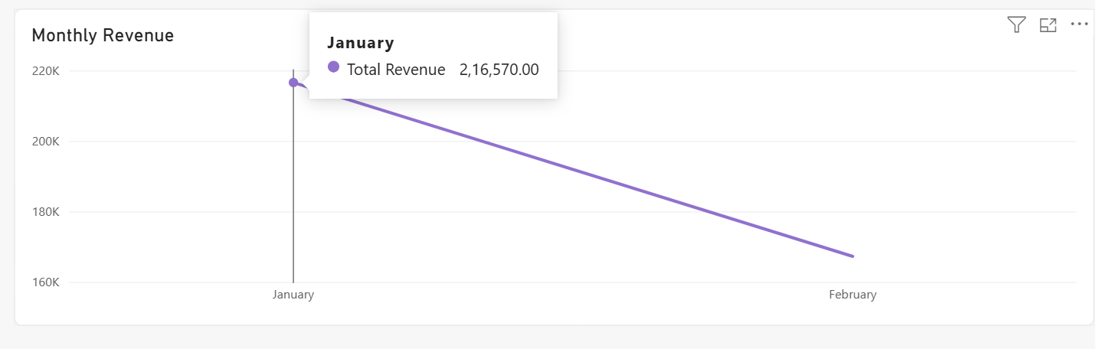
Revenue by Category
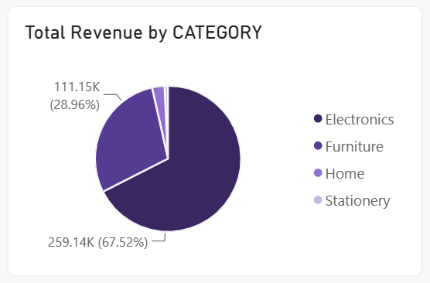
Orders by Status
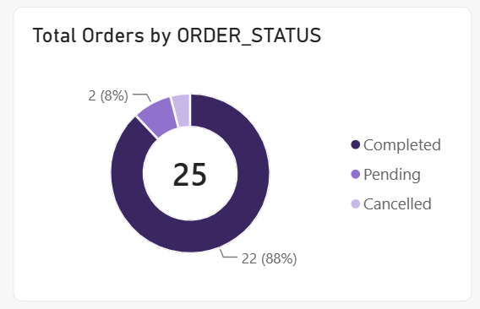

Revenue by Sales Channel
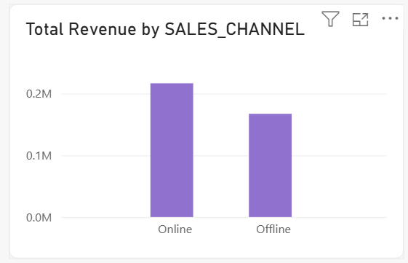
Top 5 Products by Revenue
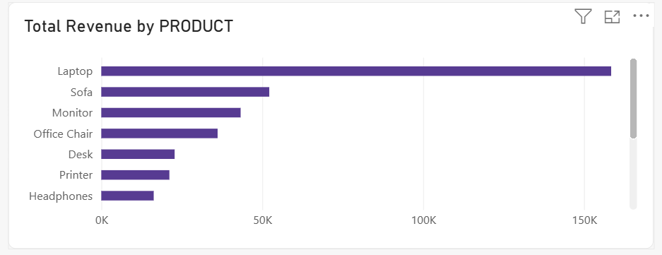
Revenue by Customer Type
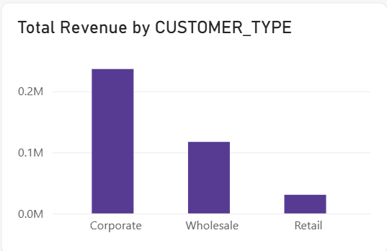

Payment Method Distribution
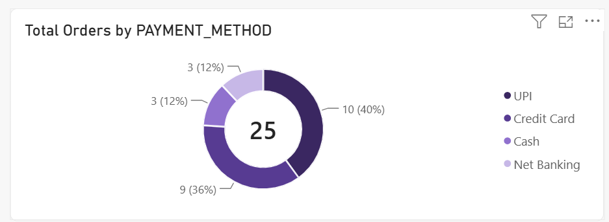

12. Apply Filters and Slicers
Dashboard before applying filters:
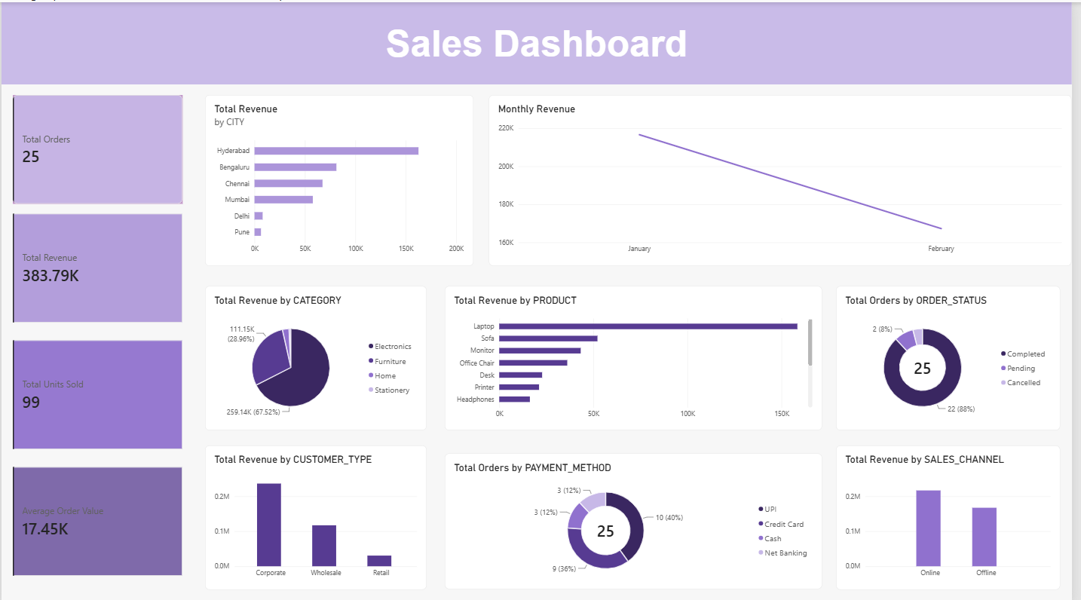

Dashboard after applying city filter:
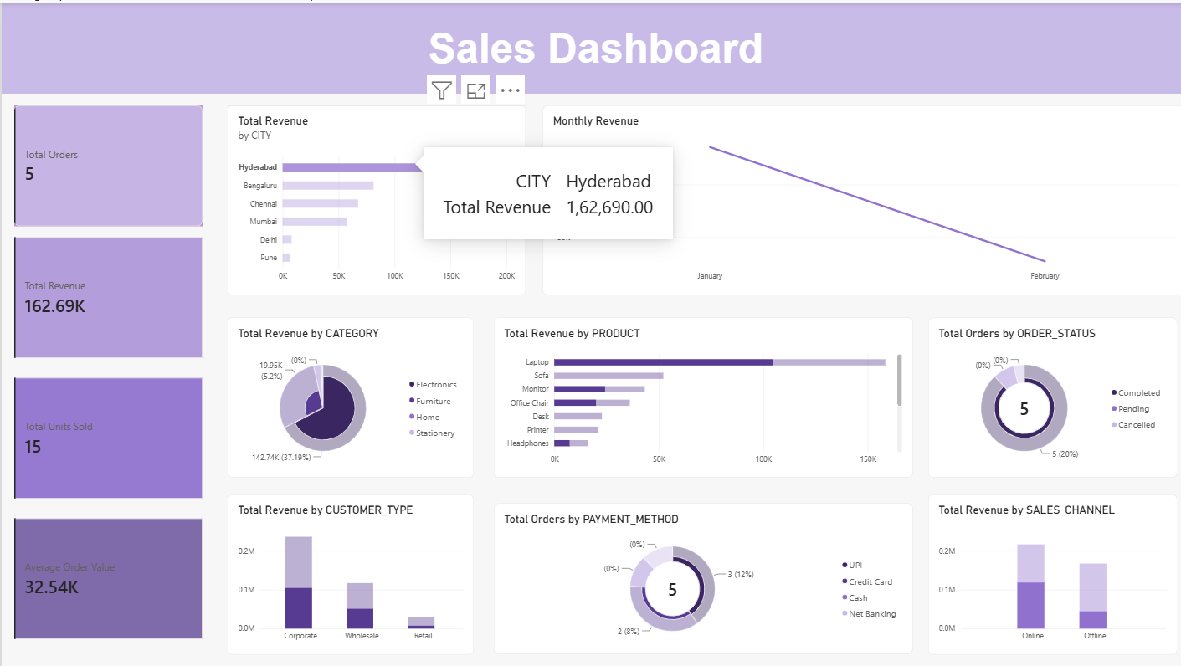

Dashboard after applying category filter:
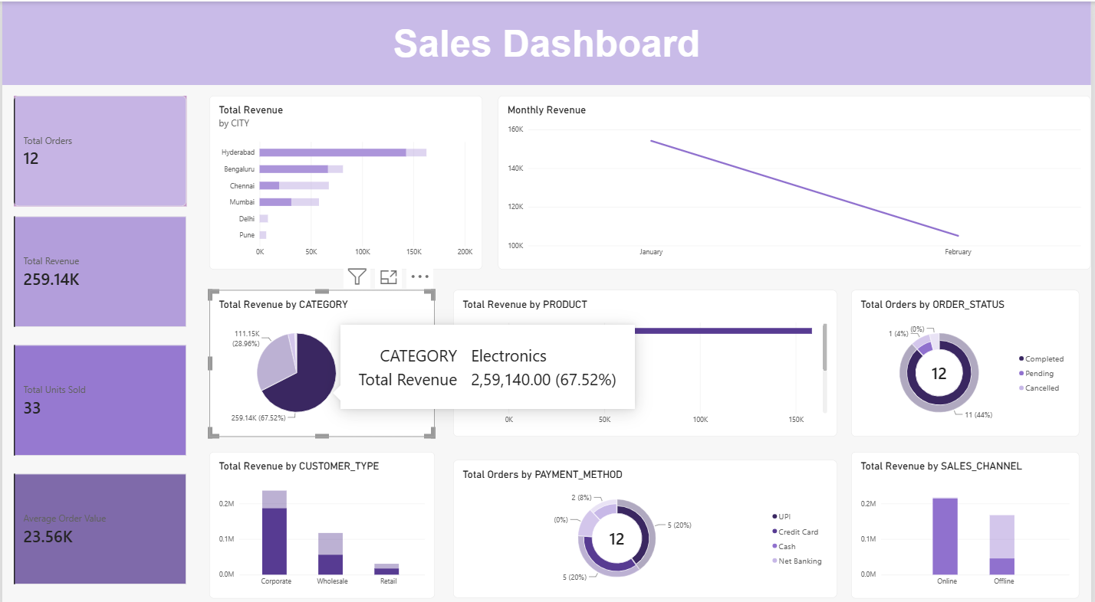

13. Format the Dashboard


